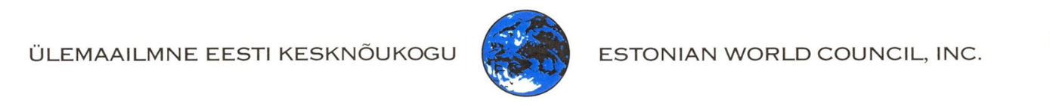

**GRANT APPLICATIONS SUBMITTED TO ÜEKN**

1. The Estonian World Council (ÜEKN) supports projects that help realize the goals of ÜEKN:
   1. to represent and unite organized Estonians outside of Estonia;
   2. to protect and preserve the interests of Estonia;
   3. to develop the national identity and cooperation of Estonians living abroad;
   4. to support the Estonian language and culture among Estonians abroad;
   5. to spread information about ÜEKN's activities and Estonian and Estonian societies abroad;
   6. support the activities of member organizations;
   7. involve new member states.
2. Project applications can be submitted by registered organizations (legal entities). Grants are not granted to private individuals.
3. To apply for support, download the application form and send it by e-mail to uekn.info@gmail.com.
4. Project applications are accepted twice a year - in January and September.
5. The board of ÜEKN reviews the submitted applications within two months and asks additional questions if necessary.
6. Approved grant amounts are transferred to the applicant's bank account within two months at the latest.
7. The beneficiary undertakes to:
   1. Submit bank account information as requested;
   2. publish the ÜEKN logo in the promotional materials of the project and on the website;
   3. submit a written content and financial report to ÜEKN within three months after the end of the project (end date);
   4. submit a short article with a few pictures of the project's activities for posting on the ÜEKN website;
   5. To repay unused funds within two months of the project end date.
8. ÜEKN publishes information about grant recipients and amounts on its website <https://uekn.ee/>

**For more information contact** [**uekn.info@gmail.com**](mailto:uekn.info@gmail.com)